Fighting Ships
and
Aerospace Craft
of the
Lycavorian Union
Fall 2574
(Update Spring/Summer 2575)


© 2010 Michael J. Cropo. All rights reserved;
Photo copyrights held by others, used with permission, see last page

CONTENTS

INTRODUCTION 1
Fleet Composition 1
Fleet Organization 4
Impact of the ARIZONA Class Strike Carriers 6
Fleet Combat Aerospace Craft 7
PART 1 Ships 9
PRALOR VORTEX CLASS HEAVY CRUISER 10
ARIZONA CLASS STRIKE CARRIERS 12
LEONIDAS IIA CLASS STRIKE CRUISER 15
LEONIDAS I CLASS ATTACK CRUISER 17
MOONLANCER-B CLASS BATTLE CRUISER (Attack Wing Variant) 19
NOVA CLASS ATTACK CRUISER 21
VANGUARD MK III INTERDICTION CRUISER CLASS 23
ADMIRAL CENEU CLASS HEAVY ATTACK DESTROYER 26
RANGER (TAUR’OHTAR) CLASS DESTROYER ESCORT MK VIII (Attack Wing Variant) 28
AUTUMN MOON CLASS ATTACK FRIGATE 30
OMEN CLASS FRIGATE 32
DROW GUARDS INTERDICTOR CLASS CORVETTE 33
STRIKER AT ATTACK TRANSPORT CLASS 34
VIPER CLASS HEAVY TROOP SHIP 36
KADEN CLASS TRANSPORT 37
WASP CLASS ASSAULT TRANSPORT 38
TYPE I DRAGON TRANSPORT (All are assigned to Arzoal) 40
TYPE IA DRAGON ATTACK TRANSPORT 1st Dragon Brigade 42
TYPE II DRAGON TRANSPORT (Assigned to the Dragon Elder Council) 44
STRIKER DT DRAGON ATTACK TRANSPORT (Mjolner’s Hand Standard) 46
STRIKER DT IIA DRAGON ATTACK TRANSPORT (Future replacement for original DT) 48
HEALER CLASS MEDICAL SHIPS 50
PART 2 Aerospace Craft 51
M7 TEMPEST FIGHTER INTERCEPTOR 52
M5A DEVASTATOR FIGHTER BOMBER 53
RAPTOR IIE3 (ELINT) 54
Photo credits: 55

TABLES

Table 1: Fleet Staffing by Ship Class 2
Table 2: Fleet Combat Flight Crew Staffing by Ship and Aerospace Craft Type 2
Table 3: Total Fleet Aerospace Craft and Minimum Flight Crew Required
by Aerospace Craft Type 2
Table 4: Fleet Assault Transport and Staffing 3
Table 5: Fleet Dragon Assault Transport and Staffing 3
Table 6: Strike Carrier Attack Wing nominal composition 7

INTRODUCTION
Updated with new information gleaned from discussions with
sources believed to be reliable
This document has been prepared from officially released data about the dimensions, loads, and performance capabilities of the Lycavorian Union’s principal combat fleet. Its publication is intended to aide those wishing understand the fleet’s capabilities as it engages our Kavalian enemies.
The following descriptions of the Union’s principle combat ship classes and aerospace craft are based on unclassified pictures and data separately provided by official Union sources as individual documents. This compilation merely consolidates the material in a convenient form.
The description of the Fleet’s composition is based on analysis of the data provided. For example, the Union did not provide composite personnel statistics. The author simply calculated the total personnel required to staff the number of ships in the class. There have not been rumors of personnel shortages, so we assume estimates are reasonable.
Similarly, the number of aerospace craft produced has never been revealed. The numbers provided here are simply those required to fill the ships’ inventory. There are likely many more for training and base defense assignments.
Some data can simply be deduced. Production data on the ships assigned to the Arizona Wing was not provided. However, an announcement of the composition of typical Arizona Attack Wings was included. One can conclude that this composition will be followed for all 20 Arizona Strike Carriers and the necessary upgraded ships are being produced.
A copy of this analysis is available.

Fleet Composition
As of late 2574, the Union Fleet consisted of over 21,100 ships assigned to fleet groups plus over 1,000 ships assigned to the new Arizona Wings under construction. These ships are staffed by over 12 million officers, 79 million enlisted personnel. (See Table 1.)
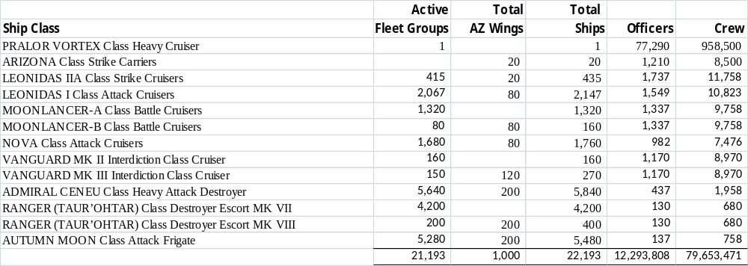
Table 1: Fleet Staffing by Ship Class
The fleet ships carry over 1.5 million flight crews supporting over 600,000 aerospace craft and are capable of carrying both Striker ATs and Striker DTs to support ground assault operations. (See Table 2 and Table 3.)
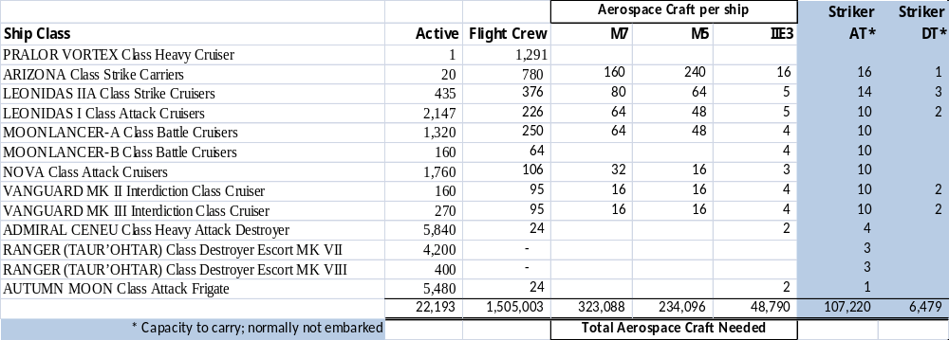
Table 2: Fleet Combat Flight Crew Staffing by Ship and Aerospace Craft Type
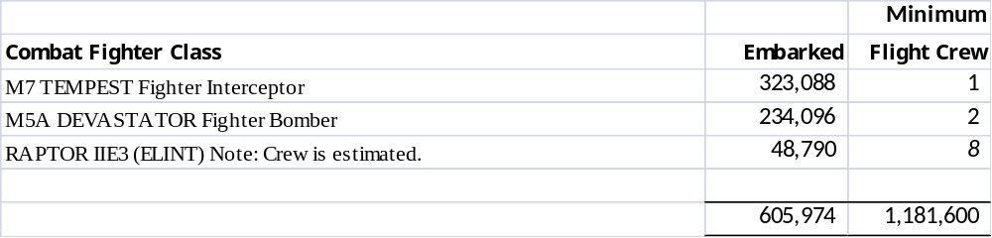
Table 3: Total Fleet Aerospace Craft and Minimum Flight Crew Required by
Aerospace Craft Type
For ground operations, the Fleet can support over 104 thousand embarked Striker attack transport craft. Additionally the Fleet is deploying a growing number of Troops Transport ships that deliver over 21 million assault troops where and when needed. (See Table 4.)
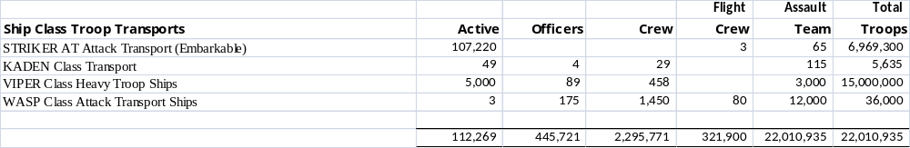
Table 4: Fleet Assault Transport and Staffing
Note that the Striker Attack Transports can be embarked on certain ship classes as the mission dictates. (See Table 2 above.) The new Wasp Class Attack Transport is a construction priority to start replacing the Viper and Kaden transports and expand our troop transport capabilities.
These assault forces can be supplemented by assault personnel supported by the 1st Dragon Brigade, 3,000 dragons. Eight Type 1A dragon transports have been constructed and dedicated to the Brigade. 350 Striker Dragon Transports were built for Mjolnir’s Hand and the Royal family. Mjolnir’s Hand has 300 riders and bonded dragons; each bonded pair has a personalized dragon transport (DT) as does each bonded dragon of the Royal family. (See Table 5 below.) One should note that the fleet can support more Striker DTs ships than have been built.
A new Striker Dragon Transport Type DT IIA has been developed with the first six being assigned to the Royal family. A less luxurious DT Type II is expected for Mjolnir’s Hand replacing the Type 1As.
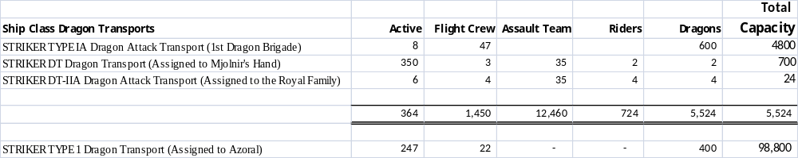
Table 5: Fleet Dragon Assault Transport and Staffing
Also included in Table 5 above are the 247 Striker Type 1 Dragon Transports. These are assigned exclusively to Elder Dragon Mother Arzoal. They are not combat ships although they have a limited self defense capability. They are intended for travel only within the Union and consequently have neither shield not shroud capabilities.
While not fighting ships, the fleet has 27 Healer Class Medical ships operating in support of ground operations and elsewhere when needed. These ships are equipped with the most advanced medical equipment anywhere in the universe. They have three thousand beds and are staffed almost entirely of Hadarian Healers.
A new MEDEVAC (medical evacuation) variant of the Striker Attack Transport is being developed and equipped with the most advanced medical facilities for combat trauma care and transport to ensure rapid recovery and transport the injured from a battle area to the Healer medical ships. Queens Anja and Eurin have devised most of the new equipment.
We have also included photos of two uncategorized ships: The first, the Omen, a highly classified intelligence gathering ship which is rarely seen and is heavily used for covert operations. The second is the even more mysterious Drow Guards Interdictor Corvette. Beyond that one photo we can find no public information on it.

Fleet Organization
The Fleet is commanded by Admiral of the Fleet Riall as needed in response to the needs of the Union as directed by the King or with his continued absence, by Crown Prince Androcles. It is generally organized in Standard Fleet Groups 0f 150-200 ships. The number of ships can vary dramatically based on the Group’s mission and alert status. Typically Lycavorian Fleet Groups appear to be somewhat smaller than the equivalent High Coven and Kavalian units. Hopefully this reflects our better training, readiness, and weaponry. Typical fleet groups are comprised of Assault Units:
Assault Units, about 40-50 ships comprised of—
- 1 Leonidas IIA Strike Cruiser
- 4 Leonidas I Attack Cruisers
- 3 Moonlancer-A Battle Cruisers
- 4 Nova Attack Cruisers
- 14 Admiral Ceneu Destroyers )
- 10 Taur’Ohtar Destroyers ) as the mission dictates.
- 14 Autumn Moon Frigates )
While Assault Units do carry out specific missions, normally three to four Assault Units are combined to form a Standard Fleet Group for most missions. Combining three to four Standard Fleet Groups form a Tactical Fleet Group. There are about 90 permanent Standard Fleet Groups.
Border Interdiction Groups are much smaller, about 15 ships. Typically they are comprised of—
- 2 Leonidas I Attack Cruiser
- 2 Moonlancer - A Battle Cruiser
- 2 Nova Attack Cruisers
- 2 Vanguard MK II Interdiction Cruisers
- 3 Taur'Ohtar Destroyers
- 3 Admiral Ceneu Destroyers
- 3 Autumn Moon Frigates
Border protection is one of the Fleet’s primary missions, with about 80 standard Border Interdiction Groups dedicated to this mission.
Ground Attack Groups are larger. Typically they are comprised of—
- 2 Leonidas IIA Strike Cruiser
- 4 Leonidas I Attack Cruisers
- 4 Moonlancer- A Battle Cruisers
- 4 Nova Attack Cruisers
- 18 Taur’Ohtar Destroyers )As needed by mission
- 18 Admiral Ceneu Destroyers )
- Plus sufficient attack and troop transport to carry and insert the necessary force, under combat conditions where necessary (see note below)
Note: Every ground assault is different. In an unopposed occupation it may be just the necessary security forces which could be as small as few tens of thousands personnel. In an opposed planetary invasion against an enemy force of 1,000,000 combat soldiers spread around the planet, you want at least a 3:1 troop advantage at every attack point. This means the invasion force may be a many as 3,000,000 troops and their equipment, needing over 1,000 Viper class troop ships. Of course, that requires many ground assault groups. The typical ground assault would have about 25 Vipers carrying 75,000 troops, their equivalent in armored brigades, or both. In larger assaults a single Ground Assault Group is capable of protecting about 30 troop transports. There are about 20 permanent Ground Attack Groups.
Ground Attack Groups are typically protected by a three fleet groups in associated escort (close but not intermingled) led by a single commander. This combination is referred to as Combined Forces Fleet Group.
About 6 to 10 Fleet Groups to appear to be dedicated to the Royal Family’s wide ranging and varied activities benefiting the Union. The King, some of his five Queens, and Princes Androcles and Resumar appear to have permanently assigned groups comprised of a command strike cruiser plus several supporting ships and craft. Other Royal Family members may be assigned a group as needed. The groups assigned to the family appear to be significantly smaller than the standard Fleet Group
Additional Fleet Group missions include:
- Defense of Earth and Apo Prime as well other key sites. Orbital Defense stations are assuming most of this role to free ships for other missions.
- Diplomatic escort duties.
- Scouting, Surveillance, and Exploration.
We estimate that in peacetime about 10-15% of the Fleet’s ships are off-line at any given time for training or refit. This means that up to 3,000 ships are in a state of less than full readiness, leaving about 18,000 ships available for full duty, which would equate to 90 Standard Fleet Groups. Of course these numbers will rise as units complete their refits and training.

Impact of the ARIZONA Class Strike Carriers
Introduction of the Arizona Class Strike Carriers earlier this year appears to be impacting standard Fleet Group structure. First, newer ships in some Fleet Groups have been pulled off the line for upgrades and retrofits needed to keep up with and support these advanced ships. These ships represent a marked leap in Lycavorian defensive and offensive capabilities. Indeed, the Strike Carrier groups are being called Attack Wings rather than Fleet Groups reflecting their offensive purpose. Further, these wings are smaller than the standard Fleet Groups. Data provided by Union officials show these wings to be a fourth of the size of a Standard Fleet Group depending on operational requirements. (See Table 6.) Nominally the wings operate with about 50 combatant ships, although their actual size will vary by mission.
When a mission dictates, additional ships can be added from the fleet or multiple Attack Wings combined. Thus, Arizona Attack Wings may have three standard configurations: A fast 50 ship attack force; a larger 60-80 fast ship strike force; and a multi-wing strike force.
When ground attack operations are envisioned, dragon and troop transports are available and assigned.
The typical Arizona Attack Wing carries more than 1950 combat aerospace craft or about a 40% of the number carried by the standard fleet group four times its size.
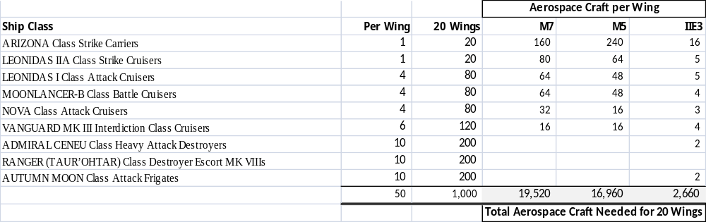
Table 6: Strike Carrier Attack Wing nominal composition
With 20 wings soon to be available, multi-wing operations are likely. At least 1,000 ships and more than 39,000 combat aerospace craft have been built or modified and dedicated to this new offensive capability. Also are equipped with the latest sensors, weapons, shroud generators, and armor.
Presumably these variable configurations reflect a quantum leap in the Strike Carrier Wing’s firepower over a nominal Fleet Group’s. Indeed, unverified rumors have indicated that the Arizona’s Attack Wing, commanded by Admiral Miranda Lorian, decimated two Kavalian Fleet Groups totaling over 400 ships at Kranek and more recently nearly 200 Kavalian ships during initial operations in Kavalian space.
Even so, the Kavalian fleet outnumbers the Union fleet nearly five to one in ships alone, not counting the 1000 ships in the Arizona Attack Wings. While the Union is used to fighting when outnumbered, these odds appear daunting. It appears the Union is counting on its advanced technology to even the odds.

Fleet Combat Aerospace Craft
The Fleet carries four types of combat aerospace craft: The M7 Tempest Fighter; M5 Devastator Fighter-Bomber and its Electronic Warfare variant, the M5 Penetrator; plus the Raptor IIE3 ELINT craft. ELINT stands for electronic intercept.
The M7 is the Union’s answer to the KFI’s Jaguars MK I and MK II. It is faster, has a longer combat range and longer range weapons with a very advance pod-based sensor system. This gives the M7 a stand-off advantage, especially with the Raptor ELINT craft giving the fleet early warning information. On the other hand, the KFI has nearly 5 times the number of Jaguars fighters and they excel at close in combat. M7 production is on-going and these craft will start to take over the M5’s fighter missions allowing the M5 to focus on its strike bombing role.
The M5 is not directly comparable to the KFI’s Black Soul Raiders. Both have bombing roles, but the Black Soul can alternatively also act as an attack transport landing 28 marines or commandos.
Unfortunately, the union M5 data provided does not include numbers for each variant nor does the ship data distinguish between these variants.
Little technical data has been provided on the Raptor except that it is extremely capable.

One final note: Curiously, Union officials provided details of a recently recovered Pralor Vortex Cruiser, now renamed ULU Sparta’s Wrath. Beyond its enormous size (it is 50 times the size of the Union’s largest ship, ULU Leonidas IIA Class), its propulsion, sensors, electronics, and weapons appear to be far beyond even the Arizona’s advanced systems. One source has said “this one ship has the destructive power of five Combined Union Fleet Groups at its disposal.” And she has apparently demonstrated this power at the Battle of the Farnuri Expanse.
How fast can the Union fleet assimilate further improvements derived from the Pralor ship? Will such improvements be enough to offset the KFI superior numbers?

The remainder of this document is in two parts: Part 1 provides details of the characteristics and performance as well as a short narrative about each ship class. Part 2 provides similar data for the Union combat aerospace craft.

PART 1 Ships

PRALOR VORTEX CLASS HEAVY CRUISER
ULU SPARTA’S WRATH (Formerly Vortex Cruiser 341)
(DREAMLAND UPDATE)
Manufacturer- Pralor Engineering
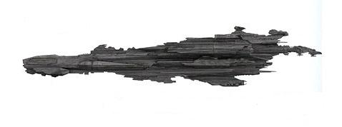
Mass- 22,400,000,000 Metric Tons
Length- 21,598 Meters
Width- 4,750 Meters
Height- 5,560 Meters
Propulsion-
- 2x Seventh Tier Phased Quantum Fusion Resonance Main Reactors
- 4x Fifth Tier Phased Quantum Fusion Resonance Secondary Reactors
- 4x Quantum Fusion Phasic sublight engines
Acceleration- Classified
Range- Classified
Compliment- 77,237 Officers; 958,758 Crew; 1,291 Flight Crew
Sensors and Processing Systems-
- Pralor Mark V Alpha Tactical Network
- Pralor Phasic Matter FCS
- Pralor engineered Quantum Processor AI Computer Core
- Hadaria Series 10 Bioscanners (Installed by Union)
- Class Four Etheric Sensor Grid
Electronic Warfare and Decoys-
- Pralor EW Nodes
- 18 Whisper class Shroud Mk VIII (Installed by Union)
- 6 Multi-Role System Decoy Launcher (Installed by Union)
- 1 Graviton Wave Emitter (Installed by Union)
Armament-
- 120 Category 1 Quantum Matter Pulse Cannon Batteries
- 200 Category 6 Quantum Matter Pulse Cannon Batteries
- 54 Quantum Matter Torpedo Bays
- 150 Quad Quantum Pulse Cannon Point Defense Turrets
- 24 Point Defense Anti-ship Quad Missile Clusters
- X2 Guided Phased Fusion Missiles with Quantum Binary warhead
Armor-
- Category 5 Bio-mechanical Ducorsis Armor Shell
- 45 Category 3 Multi-Restorative Shield Generators
- Quantum Kinetic Shielding Grid
Aerospace Craft carried (update) -
- 900 APOC Series T9 Fighter Drones
- 5 Pralor Long Range Phased Quantum Transports
- 2 Type II Dragon Transports
- 30 Stryker DT IIAs
- 16 Raptor IIE3
- 10 Menkla Class armed transports.
Number Active: 1
Update: While nearly 11,000 Vortex Cruisers were built, SPARTA'S WRATH was the latest and only known example of this variant. Historical records discovered during a recent LU Dreamland Update indicate it is unique and was intended to be the start of a new class of Pralor heavy cruisers. These records indicate at least other keels were laid down. No records indicate whether these were ever completed.
In addition to the revised air groups and associated changes to hanger bays and launching systems, there have been major changes to engineering spaces as well as berthing realignments to enhance crew habitability.
10,941 VORTEX-Class Heavy Cruisers were built by the Pralor species. The heaviest class of ship that their species operated among their 300,000 strong galaxy spanning fleet. Given that new data from Prince Androcles suggests the Pralor empire comprised over a hundred trillion different lifeforms and six hundred Systems, a fleet of 300,000 ships seems miniscule. VORTEX Cruiser 341 was the first and the last warship built by the Pralor species that combined their most advanced level of technology and designs. It was to be the crowning example of their level of knowledge. With the Seventh Tier Phased Quantum Fusion Resonance Main Reactors providing nearly limitless power, the VORTEX-Class Heavy Cruiser SPARTA’S WRATH (Renamed by Avatar 341 with permission of Resumar Leonidas) was to be the first of many such ships built, designed to take back all they had lost and eventually defeat the Scourge. The ship was designed far too late however, as one year after its final construction was completed and it was to take its maiden voyage, the end of the Pralor species came to be when their home world was lost in a brutal surprise attack and the genocide of their entire race began.

ARIZONA CLASS STRIKE CARRIERS
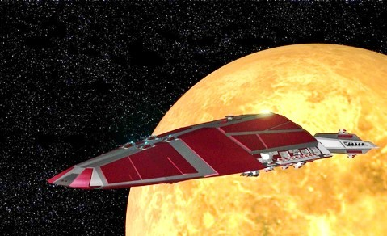
Manufacturer- Dreamland Shipyards
Mass- 900,000,000 Metric Tons
Length- 3500 Meters
Width- 1750 Meters
Height- 560 Meters
Propulsion-
    - x2 Quantum Resonance Field Reactors
    - x8 Matter Furnace Reactors
    - x4 Plasma Sublight Engines in 2 nacelles
Acceleration- Classified
Range- 60,000 Light Years
Compliment- 1,210 Officers, 8,500 Crew, 780 Flight Crew
Sensors and Processing Systems-
- Nodon JCN Type 71 Tactical Network
- NorthAm Mk X Aegis FCS
- Li’an class XXV Computer Core
- Hadaria series Bioscanners
Electronic Warfare and Decoys-
- 4 Black Sun Mk XVII EW Nodes
- 8 Whisper class Shroud Mk VIII
- 2 Multi-Role System Decoy Launcher
- 1 Graviton Wave Emitter
Armament-
- 20 Type 1 Plasma Turrets (Terra Series)
- 30 Type 2 Plasma Turrets (Terra Series)
- 4 Missile Batteries w/10 missile bays each
- 16 Photonic Torpedo Launchers
- 60 Quad Pulse Cannon Point Defense Turrets
- 20 5 Rack Point Defense Missile Clusters
Armor–
- Laminated Crystanium Weave with Dragon Armor Core and Stealth Sheath
- Eight Type 90 Shield Generators
Aerospace Craft Carried-
- 10 Squadrons (160) M7 Tempest Interceptors
- 15 Squadrons (240) M5 Devastator Strike Fighters
- 16 STRIKER ATRs
- 16 Raptor IIE3 (ELINT)
- 2 STRIKER DT
- Docking Collars for Nodon Eng. Type I DT
Number Active 6
Intrepid, Essex, Hood, and Enterprise will be operational by year’s end and the rest of ships by mid-summer 2575.
Commissioning Schedule:
Ship Name- Hull Status
BLOCK I (64 Aerospace launch tubes – to be upgraded to 128)
Arizona (Class ship) SCV-01 Commissioned
Hornet SCV-02 Commissioned
Bismarck SCV-03 Commissioned
Yamato SCV-04 Commissioned
Missouri SCV-05 Commissioned
BLOCK II (128 Aerospace launch tubes)
Intrepid SCV-06 Awaiting Fighter Wing
Essex SCV-07 Awaiting Fighter Wing
Arc Royal SCV-08 Commissioned without Fighter Wing
Hood SCV-09 Awaiting Fighter Wing
Enterprise SCV-10 Awaiting Fighter Wing
Ise SCV-11 Awaiting power plant
Shinano SCV-12 Awaiting power plant
Tripitz SCV-13 Awaiting power plant
Warspite SCV-14 Awaiting power plant
Repulse SCV-15 Awaiting power plant
Lexington SCV-16 Awaiting power plant
Saratoga SCV-17 Awaiting power plant
Yorktown SCV-18 Awaiting power plant
Iowa SCV-19 Awaiting power plant
Musashi SCV-20 Awaiting power plant
The Arizona Project began as the brainchild of General Ben O’Conner. Realizing the lack of a carrier class ship in the Union Fleet, he began a secret research project on Earth prior to the Evolli War. The first prototype was built from the plans of a previous design, the Victorious Class Cruiser, a design that was rejected in favor of the Leonidas I Class Cruiser. The plans were transferred to the Wolf 359 shipyards a year before the end of the Evolli war and Ben’s design team immediately went to work. Repeated tests and overhauls of the design followed, and three years after the end of the Evolli War, the first prototype was commissioned for proving trials.
The ships were primarily carriers, bringing 25 squadrons into the battle space, but they were also heavily armored and well armed for following the fighters into battle. Many of the systems that occupy the Arizona Class were derived from the Mindvoice Ship known as CS41, as were her main drives and integrated networks. While the mysteries of the Quantum Drive were still beyond Union Engineers, with the Avatar Avi’s help the advances in LSD technology incorporated in the new class would give the Union unparalleled first strike capability as well as the ability to rapidly respond to any situation. Command was given to Star Commander Miranda ‘Mando’ Lorian, a young RiStar (Rising Star) in the Union Fleet, to prove the validity of the design to Fleet Admiral Riall and King Leonidas, who would have final say over the fate of the design.
Four other ships were built (Hornet, Bismarck, Yamato, and Missouri), all named after the ancient hulls of the Victorious class. The four ships entered the proving grounds at Wolf 359, the Fleet’s main training ground for the Sol Sector. The trials were scheduled to last for six months; however, galactic events soon called these unique warships to battle quicker that anyone would anticipate save for a select few.
Based on the early experience of the Arizona wing, the Block II designs was modified to double the aerospace craft launch tubes in order to speed launching the embarked craft and numerous minor changes were incorporated. The Block I ships will be modified as the availability permits.

LEONIDAS IIA CLASS STRIKE CRUISER
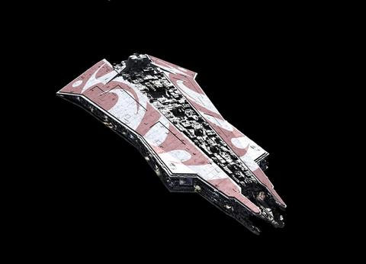
Manufacturer- Nodon Engineering Corporation
Mass- 1,400,000,000 Metric Tons
Length- 4300 Meters
Width- 1950 Meters
Height- 560 Meters
Propulsion-
    - 4x Class Six Hyper Matter Fusion LSD (Light Speed Drive) Coil Reactors
    - 4x NEC Y74 Phased Plasma Sublight Engines in 2 Lateral Nacelles
    - 2x NEC Y71 Phased Plasma Sublight Emergency Engine Inline Nacelles
Acceleration Classified
Range- 60,000 Light Years
Compliment- 1,737 Officers; 11,758 Crew; 376 Pilots
Sensors and Processing Systems-
- Nodon Engineering JCN Type 71 Tactical Networks
- NorthAm Mk X Aegis FCS
- Li’an Class XXV Computer Core
- Hadarian Series Nine Bioscanners and Biofilters
Electronic Warfare and Decoys-
- Black Sun Mk XVII EW Nodes
- 4 Whisper Class Mk VIII Shroud Generators
- TOPA Multi-Role System Decoy Launcher
Armament-
- 60 Type 1 Plasma Turrets (MK9C Alpha Series 1) 25 Port Side, 25 Starboard Side,
5 Forward, 5 Aft
- 30 Type 2 Plasma Turrets (MK9C Alpha Series 3)
- Mark 22B Anti-Ship Missile Batteries w/23 Launchers per side.
- 18 Photonic Torpedo Launchers
- 20 Quad Pulse Cannon Point Defense Turrets
- 2 5 Rack Point Defense Missile Clusters, 1 Forward, 1 Aft
Armor-
- Depleted Laminate Crystanium Weave molded with inner and outer Layers of Dragon Armor
- Eight Type 90 Shield Generators

Aerospace Craft Carried-
- 5 Squadrons (80) M7 Tempest Interceptors (Replaces T9E)
- 4 Squadrons (64) M5 Devastator Heavy Strike Fighter/Bomber (Replaces M4B)
- 14 STRIKER ATRs
- 5 Raptor IIE3 (ELINT)
- 3 STRIKER DT
- Docking Collar for Nodon Eng. Type I DT
Number Active: 435
The newest and most powerful Command and Control warship for the Union Fleet, the SCIMITAR is a Leonidas IIA-Class Strike Cruiser, the letter A simply designating it as a Command ship for a Spartan Combined Forces Fleet Group, or SCFFG. It will rapidly replace all of the Leonidas I-Class Cruisers within the inventory, leaving the Leonidas I-Class to return to its original role as a Heavy Interdictor Class Orbital Ground Forces Command ship.

LEONIDAS I CLASS ATTACK CRUISER
Manufacturer- Nodon Engineering Corporation
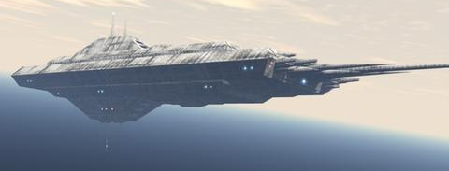
Mass- 322,000,000 Metric Tons
Length- 3600 Meters
Width- 1450 Meters
Height- 460 Meters
Propulsion-
    - 4x Class Six Hyper Matter Fusion LSD (Light Speed Drive) Coil Reactors
    - 6x NEC Y74 Phased Plasma Sublight Engines in 2 Lateral Nacelles
    - 2x NEC Y71 Phased Plasma Sublight Emergency Engine Inline Nacelles
Acceleration- Classified
Range- 60,000 Light Years
Compliment- 1,549 Officers; 10,823 Crew; 226 Pilots
Sensors and Processing Systems-
- Nodon Engineering JCN Type 71 Tactical Networks (Refit)
- NorthAm Mk X Aegis FCS (Refit)
- Li’an Class XXV Computer Core (Refit)
- Hadarian Series Nine Bioscanners and Biofilters (Refit)
Electronic Warfare and Decoys-
- Black Sun Mk XVII EW Nodes (Refit)
- 4 Whisper Class Mk VIII Shroud Generators (Refit)
- TOPA Multi-Role System Decoy Launcher (Refit)
Armament-
- 50 Type 1 Plasma Turrets (MK9C Alpha Series 1) 20 Port Side, 20 Starboard Side,
5 Forward, 5 Aft
- 30 Type 2 Plasma Turrets (MK9C Alpha Series 3)
- Mark 22B Anti-Ship Missile Batteries w/16 Launchers per side.
- 14 Photonic Torpedo Launchers
- 20 Quad Pulse Cannon Point Defense Turrets
- 2 5 Rack Point Defense Missile Clusters, 1 Forward, 1 Aft
Armor-
- Depleted Laminate Crystanium Weave molded with inner and outer Layers of Dragon Armor
- Eight Type 90 Shield Generators

Aerospace Craft Carried-
- 4 Squadrons (64) M7 Tempest Interceptors (Replaces T9E)
- 3 Squadrons (48) M5 Devastator Heavy Strike Fighter/Bomber (Replaces M4B)
- 10 STRIKER ATRs
- 5 Raptor IIE3 (ELINT)
- 2 STRIKER DT (Structural Refit of Decks seventeen through twenty-one only)
- Docking Collar for Nodon Eng. Type I DT
Number Active: 2,127
The Predecessor to the Leonidas II, a ship built to take a beating and give better than it takes. Though being replaced by the Leonidas II, many commanders swear by the reliability of this class ship.

MOONLANCER-B CLASS BATTLE CRUISER
(Attack Wing Variant)
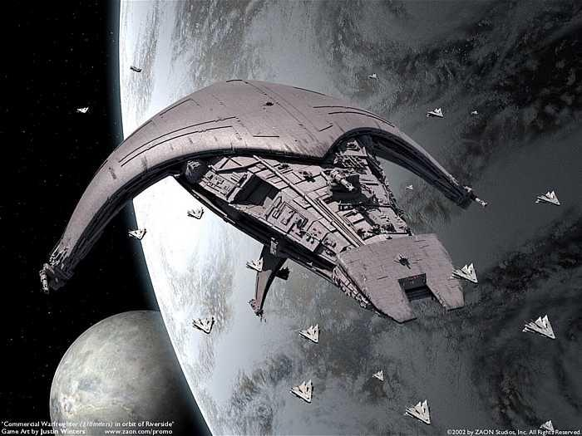
Manufacturer- Acamarian Dynamic Systems
Mass- 296,000,000 Metric Tons
Length- 2400 Meters
Width- 1250 Meters
Height- 360 Meters
Propulsion-
- 4x Class Six Hyper Matter Fusion LSD (Light Speed Drive) Coil Reactors
- 3x NEC Y74 Phased Plasma Sublight Engines in 2 Lateral Nacelles
- 2x NEC Y71 Phased Plasma Sublight Emergency Engine Inline Nacelles
Acceleration- Classified
Range- 60,000 Light Years
Compliment- 1,337 Officers; 9,758 Crew; 64 Flight Crew; and 650 Assault Troops as needed
(250 Flight Crew - A variant ships)
Sensors and Processing Systems-
- Nodon Engineering JCN Type 71 Tactical Networks (Refit)
- NorthAm Mk X Aegis FCS (Refit)
- Li’an Class XXV Computer Core (Refit)
- Hadarian Series Nine Bioscanners and Biofilters
Electronic Warfare and Decoys-
- Black Sun Mk XVII EW Nodes (Refit)
- 2 Whisper Class Mk VIII Shroud Generators (Refit)
- TOPA Multi-Role System Decoy Launcher (Refit)
Armament-
- 100 Mk 22 Missile Launchers and high capacity magazines (B variant ships only)
- 40 Terra series Mk III dual gun turrets, 15 Port Side, 15 Starboard Side, 5 Forward, 5 Aft
- 30 Type 2 Plasma Turrets (MK9C Alpha Series 3)
- Mark 22B Anti-Ship Missile Batteries w/8 Launchers per side.
- 12 Photonic Torpedo Launchers
- 20 Quad Pulse Cannon Point Defense Turrets
Armor-
- Depleted Laminate Crystanium Weave molded with inner and outer Layers of Dragon Armor
- Eight Type 90 Shield Generators
Aerospace Craft Carried-
- 4 Squadrons (64) M7 Tempest Interceptors (A Variant ships only)
- 3 Squadrons (48) M5 Devastator Heavy Strike Fighter/Bomber (A Variant ships only)
- 10 STRIKER ATRs
- 4 Raptor IIE3 (ELINT)
- Docking Collar for Nodon Eng. Type I DT
Number Active:
- Type -A: 1,260
- Type –B: 160
The first was built two thousand years ago as the first major warship program and many of those ships are still in service today as planetary defense ships. Designed mainly as the primary fighter carrier at its inception, it was restructured as a Battle Cruiser with serious fighter support when the Leonidas I came into service. Still a solid contributor to the Union Fleet, especially with the refit of systems most of them have gone through.
NOTE: The Moonlancer-B was one of the many new upgrades that were planned for the Union Fleet. With the Arizona serving as carrier for the Assault Wing, the role of the Moonlancer in providing aerospace craft for the fleet was diminished. Therefore, the B variant of the Moonlancer removed the majority of hanger space of the fighters it carried and replaced them with 100 Mk 22 Missile Launchers and high capacity magazines. Each ship can maintain a sustained bombardment for twenty minutes before the ship’s magazines become critical. The standard Alpha series turrets were replaced with Terra series cannons, and a majority of the ship’s systems were upgraded for increased automation. This has reduced the number of flight crew and aerospace maintenance staff assigned as well as the number of ship officers and crew. In addition the Moonlancer-Bs received several classified improvements that result in extending its operational range.
While the B variant was designed expressly for support of the Arizona class, the success of the variant in battle has warranted converting additional older A variants to provide added missile capabilities to the standard fleet groups.

NOVA CLASS ATTACK CRUISER
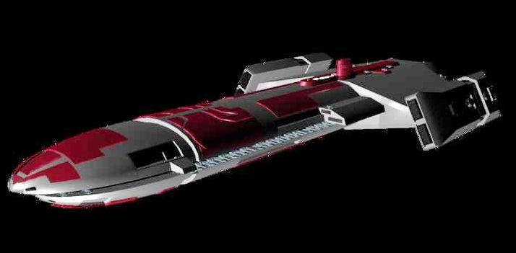
Manufacturer- Acamarian Engineering
Mass- 190,000,000 Metric Tons
Length- 1800 Meters
Width- 950 Meters
Height- 260 Meters
Propulsion-
- 3x Class Six Hyper Matter Fusion LSD (Light Speed Drive) Coil Reactors
- 3x NEC Y74 Phased Plasma Sublight Engines in 2 Lateral Nacelles
- 2x NEC Y71 Phased Plasma Sublight Emergency Engine Inline Nacelles

Acceleration- Classified
Range- 60,000 Light Years
Compliment- 982 Officers; 7,476 Crew; 106 Pilots
Sensors and Processing Systems-
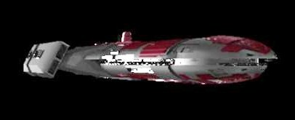
- Nodon Engineering JCN Type 71 Tactical Networks (Refit)
- NorthAm Mk X Aegis FCS
- Li’an Class XXV Computer Core
- Hadarian Series Nine Bioscanners and Biofilters
Electronic Warfare and Decoys-
- Black Sun Mk XVII EW Nodes
- 2 Whisper Class Mk VIII Shroud Generators
- TOPA Multi-Role System Decoy Launcher
Armament-
- 30 Type 1 Plasma Turrets (MK9C Alpha Series 1) 15 Port Side, 15 Starboard Side
- 30 Type 2 Plasma Turrets (MK9C Alpha Series 3)
- Mark 22B Anti-Ship Missile Batteries w/23 Launchers per side.
- 8 Photonic Torpedo Launchers
- 10 Quad Pulse Cannon Point Defense Turrets
- 1 5 Rack Point Defense Missile Clusters Center Mount
Armor-
- Depleted Laminate Crystanium Weave molded with inner and outer Layers of Dragon Armor
- Six Type 90 Shield Generators
Aerospace Craft Carried-
- 2 Squadrons (32) M7 Tempest Interceptors (Replaces T9E)
- 1 Squadron (16) M5 Devastator Heavy Strike Fighter/Bomber (Replaces M4B)
- 10 STRIKER ATRs
- 3 Raptor IIE3 (ELINT)
Number Active: 1,680
One of the mainstays of the Lycavorian Fleet. Tough, maneuverable, and very well armed.

VANGUARD MK III INTERDICTION CRUISER CLASS
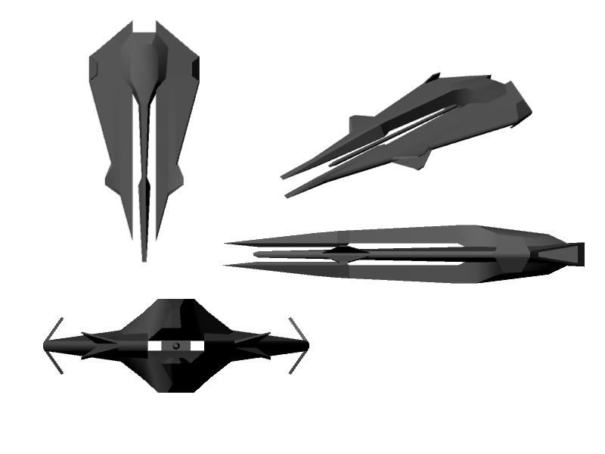
Manufacturer- Nodon Engineering Corporation
Mass- 296,000,000 Metric Tons
Length- 1,650 Meters
Width- 900 Meters
Height- 320 Meters
Propulsion-
- 3 Class Six Hyper Matter Fusion LSD (Light Speed Drive) Coil Reactors
- 1 Class Four Hyper Matter Fusion Coil Reactor for Spinal Mount
- 2 NEC Y74 Phased Plasma Sublight Engines in 2 Lateral Nacelles
- 2 NEC Y71 Phased Plasma Sublight Emergency Engine Inline Nacelles
Acceleration- Classified
Range- 60,000 light years
Compliment- 1,170 Officers; 8,970 Crew; 95 flight crew; capable of carrying 25 dragons and 650 assault troops
Sensors and Processing Systems-
- Nodon JCN Type 71 Tactical Network
- NorthAm Mk X Aegis FCS
- Li’an class XXV Computer Core
- Hadaria series Bioscanners and Biofilters
Electronic Warfare and Decoys-
- 4 Black Sun Mk XVII EW Nodes
- 8 Whisper class Shroud Mk VIII
- TOPA Multi-Role System Decoy Launcher
- 1 Graviton Wave Emitter (MK III Variant Ships Only)
Armament-
- 40 Type 1 Plasma Turrets (MK9C Alpha Series 1) 15 Port Side, 15 Starboard Side,
5 Forward, 5 Aft (MK III Variant Ships Only)
- 1 Dual Heavy Gauss Cannon (MK II Variant Ships Only)
- 1 Inferno Series Heavy Neutron Laser (Spinal Mount) (MK I Variant Ships Only)
- 30 Type 2 Plasma Turrets (MK9C Alpha Series 3)
- Mark 22B Anti-Ship Missile Batteries w/12 Launchers per side (MK III Variant Ships Only)
- 12 Photonic Torpedo Launchers
- 10 Quad Pulse Cannon Point Defense Turrets
- 2 5 Rack Point Defense Missile Clusters, 1 Forward, 1 Aft
Armor-
- Depleted Laminate Crystanium Weave molded with inner and outer Layers of Dragon Armor
- Eight Type 90 Shield Generators
Aerospace Craft Carried-
- 1Squadron (16) M7 Tempest Interceptors
- 1 Squadron (16) M5 Devastator Heavy Strike Fighter/Bombers
- 4 Raptor IIE3 (ELINT)
- 10 STRIKER ATs
- 2 STRIKER DTs
Number Active:
- MK I: 0
- MK II: 160
- MK III: 150
The Vanguard was initially built for a war never fought. But its modular nature lends itself upgrades. Entering service in 2525, the Vanguard class was designed to support the Union’s Wall of Battle. Armed with a weapon designed specifically to combat High Coven warships, the Inferno Series Heavy Neutron Laser, the Vanguard was to bombard High Coven ships with the Neutron Laser. The Vanguard proved itself in the Battle for Earth, and the design was the basis for the LEONIDAS II Strike Cruiser. The Vanguards carry two squadrons of fighters, mainly for point defense and reconnaissance. The Vanguard is a fast ship, almost a Fast Cruiser instead of a Heavy Cruiser, and is capable of keeping up with the Autumn Moons while on patrol.
Note on Neutron Lasers: Laser weapons are highly effective against unshielded targets, and can carve ships into pieces given the time to accomplish the task. Neutron Lasers were doubly effective against High Coven ships since the secondary effect of the Lasers is to saturate the target with Neutron radiation, which is lethal to Vampires. As a result, there were no Vampires assigned to any Vanguard MK I ship, and very rarely assigned to fleet groups that have these Vanguards in their ranks. After the Battle for Earth, the Vanguards were often tasked with leading raids against fortified targets and convoys, saturating the target with the Neutron Laser.
Normally, the Vanguards operated with wings of ten to fifteen ships, using its speed to respond rapidly to situations around the Union and in missions from Survey to Border Interdiction.
The Vanguards have been upgraded to function as multi-role cruisers, operating alone or with strike wings. The MK I variant was retired, upgraded to the MK II or demilitarized for civilian use. In the MK II variant the spinal mounted Neutron Laser spinal mount was replaced with a Dual Heavy Gauss Cannon similar to what is used on Kavalian warships to ensure the safety of vampires joining the Union fleet. It was replaced with the Plasma Turrets (MK9C Alpha Series 1) creating the MK III variant. The MK III will take the place of the older LEONIDAS I as escorts in our Fleet Groups. She will complement the LEONIDAS I in its role as an interdiction cruiser. Fitted with the Arizona class sensors, processors, and EW suites and with LEONIDAS II class armament, the VANGUARD MK III packs a heavy punch coupled with defensive staying power in a hull that’s smaller than the LEONIDAS I. She can go places a LEONIDAS II can’t.

ADMIRAL CENEU CLASS HEAVY ATTACK DESTROYER
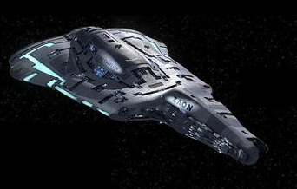
Manufacturer- Acamarian Engineering
Mass- 11,000,000 Metric Tons
Length- 800 Meters
Width- 380 Meters
Height- 160 Meters
Propulsion-
- 2x Class Six Hyper Matter Fusion LSD (Light Speed Drive) Coil Reactors
- 2x NEC Y74 Phased Plasma Sublight Engines in 2 Lateral Nacelles
- 1x NEC Y71 Phased Plasma Sublight Emergency Engine Inline Nacelles
Acceleration- Classified
Range- 60,000 Light Years
Compliment- 437 Officers; 1,958 Crew; 24 Pilots
Sensors and Processing Systems-
- Nodon Engineering JCN Type 71 Tactical Networks
- NorthAm Mk X Aegis FCS
- Li’an Class XXV Computer Core
- Hadarian Series Nine Bioscanners and Biofilters
Electronic Warfare and Decoys-
- Black Sun Mk XVII EW Nodes
- 4 Whisper Class Mk VIII Shroud Generators
- TOPA Multi-Role System Decoy Launcher
Armament-
- 20 Type 1 Plasma Turrets (MK9C Alpha Series 1) 10 Port Side, 10 Starboard Side
- 20 Type 2 Plasma Turrets (MK9C Alpha Series 3)
- Mark 22B Anti-Ship Missile Batteries w/5 Launchers per side.
- 8 Photonic Torpedo Launchers
- 10 Quad Pulse Cannon Point Defense Turrets
- 1 5 Rack Point Defense Missile Clusters, 1 Center Aft
Armor-
- Depleted Laminate Crystanium Weave molded with inner and outer Layers of Dragon Armor
- Four Type 90 Shield Generators
Aerospace Craft Carried-
- 4 STRIKER ATRs
- 2 Raptor IIE3 (ELINT)
Number Active: 5,640
The newest class ship in the Lycavorian Fleet and named for the Algolian Admiral due to his heroic exploits during the Evolli War. Fast, heavily armed, and very tough, they make a perfect complement to Fleet Groups as outlying picket ships and deep raiders.

RANGER (TAUR’OHTAR) CLASS DESTROYER ESCORT
MK VIII (Attack Wing Variant)
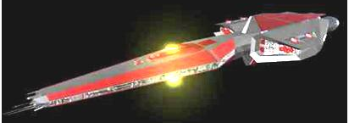
Manufacturer: Elear Defense Systems
Mass: 6,000,000 Metric Tons
Length: 650 Meters
Width: 200 Meters
Height: 125 Meters
Propulsion:
- x2 Class Four Hyper Fusion LSD Coil Reactors
- x2 NEC Y65 Plasma Sublight inline Engines
Acceleration: Classified
Range: 60,000 Light Years
Compliment: 130 Officers, 680 Crew, 12 Pilots
Sensors and Processing Systems-
- EDS Synaptic Core Type III Tactical Network
- NorthAm Mk IX Aegis FCS
- Li’an Series VII Computer Core
- Hadarian Series Seven Bioscanners and Biofilters
Electronic Warfare and Decoys-
- Black Sun Mk XVII EW Nodes
- 3 Whisper class Mk VII Shroud Generators
Armament-
- 12 Terra Series Mk IV dual Plasma Cannons turrets (Deka series MK III on MK VII ships)
- Photonic Torpedo Launchers (Turret Mounted)
- 8 Quad Pulse Cannon Point Defense Turrets
- 2 5 Rack Point Defense Missile Cluster
Armor-
- Depleted Laminated Crystanium Armor with Inner Dragon Armor Core and Exterior Stealth Weave
- Four Type 90 Shield Generators
Aerospace Craft Carried-
- 3 STRIKER ATRs
Number Active-
- MK VII: 4,200
- MK VIII: 200
One of the oldest designs in the Union, the Taur’Ohtar began life as a fast exploration vessel build by the Elves of Elear. As newer ships came online, the Taur’Ohtar was relegated to defensive duties, diplomat protection, and high-speed cargo.
The engineers behind the Arizona Project took a few of the old ships and gave them new life as a Destroyer Escort. Giving the entire ship a new weapons load out coupled with Dragon Armor, the reborn Taur’Ohtar passed the builders trials with flying colors, with the first twenty Mk VIIIs being deployed to the Royal Family’s Strike Wings. The original Deka series Plasma Cannons on the Mk VII hulls were replaced with Terra Series Mk IVs capable of rapid salvo fire against ships half its size as a test. Most Mk VIIs have been converted to the new turret configuration. Eight forward firing torpedo tubes round out the offensive side, with eight quad PDGs and two five rack PDMs rounding out the defensive mix. Aerospace assets are limited to three STRIKER ATRs, but the Taur’Ohtar is capable of recovering downed pilots for return to their ship.
In addition the MK VIIIs have received several classified improvements that result in tripling its operational range enabling it to stay with the long range mission of the Arizona wings. They have also received the newest EW and shroud generators used by the wings as well as the latest Dragon and stealth weave armor.
Some older Taur’Ohtar ships have been demilitarized and provided to local governments for use as police cruisers and diplomatic couriers.

AUTUMN MOON CLASS ATTACK FRIGATE
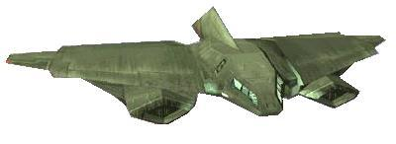
Manufacturer- Nodon Engineering Corporation
Mass- 600,000 Metric Tons
Length- 270 Meters
Width- 110 Meters
Height- 60 Meters
Propulsion-
- 2x Class Six Hyper Matter Fusion LSD (Light Speed Drive) Coil Reactors
- 4x NEC Y74 Phased Plasma Sublight Engines in 2 Lateral Nacelles
- 1x NEC Y71 Phased Plasma Sublight Emergency Engine Inline Nacelles
Acceleration- Classified
Range- 60,000 Light Years
Compliment- 137 Officers; 758 Crew; 24 Pilots
Sensors and Processing Systems-
- Nodon Engineering JCN Type 71 Tactical Networks
- NorthAm Mk X Aegis FCS
- Li’an Class XXV Computer Core
- Hadarian Series Nine Bioscanners and Biofilters
Electronic Warfare and Decoys-
- Black Sun Mk XVII EW Nodes
- 2 Whisper Class Mk VIII Shroud Generators
- TOPA Multi-Role System Decoy Launcher
Armament-
- 10 Type 1 Plasma Turrets (MK9C Alpha Series 1) 4 Port Side, 4 Starboard Side, 1 Forward, 1 Aft
- 3 Type 2 Plasma Turrets (MK9C Alpha Series 3)
- Mark 22B Anti-Ship Missile Batteries w/2 Launchers.
- 6 Photonic Torpedo Launchers
- 2 Quad Pulse Cannon Point Defense Turrets
Armor-
- Depleted Laminate Crystanium Weave molded with inner and outer Layers of Dragon Armor
- Two Type 90 Shield Generators
Aerospace Craft Carried-
- 1 STRIKER ATRs
- 2 Raptor IIE3 (ELINT)
Number Active: 5,280
Widely recognized as the fastest and most maneuverable warship within the Union Fleet until the STRIKERS came into being. With the most sophisticated sensors and Shrouds available, the Autumn Moon makes for an excellent Special Operations platform as well as deep penetration raids. Extremely deadly even for capital class ships if used in packs of three or more.

OMEN CLASS FRIGATE
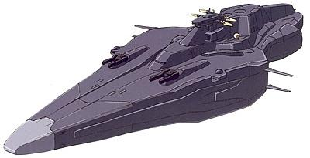
The most advanced Intelligence Gathering platform ever built. Seven of the OMEN class exist, although only six are actively used. Fast, heavily armored, and next to impossible to detect, they are the eyes and ears of the Union military and their King's Spear Tip.
Technical dimension, load, and performance data have not been released and are presumed to be classified.

DROW GUARDS INTERDICTOR CLASS CORVETTE
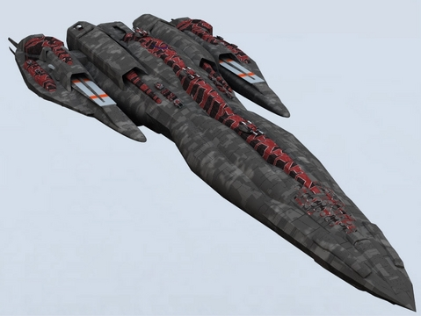
Beyond this picture and type information, no technical dimension, load or performance data has been released and are presumed to be classified.

STRIKER AT ATTACK TRANSPORT CLASS
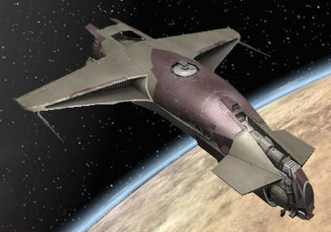
Manufacturer- Nodon Engineering Corporation
Mass- 7,000 Metric Tons
Length- 48 Meters
Width- 25 Meters
Height- 16 Meters
Propulsion-
- 1x Class Six Hyper Matter Fusion LSD (Light Speed Drive) Coil Reactors
- 2x NEC Y74 Phased Plasma Sublight Engines in 2 Lateral Nacelles
Acceleration- Classified
Range- 50,000 Light Years
Compliment- 2-3, Pilot, Co-pilot, Flight Engineer. 65 Member Assault Team Standard; 100 if needed.
Sensors and Processing Systems-
- Nodon Engineering JCN Type 51 Tactical Networks
- NorthAm Mk X Aegis FCS
- Li’an Class XXIV Computer Core
- Hadarian Series Nine Bioscanners and Biofilters
Electronic Warfare and Decoys-
- Black Sun Mk XVII EW Nodes
- 2 Whisper Class Mk VIII Shroud Generators
- TOPA Multi-Role System Decoy Launcher
Armament-
- 4 Type 2 Plasma Turrets (MK9C Alpha Series 1) 2 Port Side Forward and Aft,
2 Starboard Side Forward and Aft
- Mark 22B Full Arc Anti-Ship Missile Batteries with 2 Launchers.
- 2 Photonic Torpedo Launchers
- 2 Quad Pulse Cannon Point Defense Turrets
Armor-
- Depleted Laminate Crystanium Weave molded with inner and outer Layers of Dragon Armor
- Two Type 90 Shield Generators
Aerospace Craft Carried- None
Number Active: 104,120
The Standard Heavy Ground Support aircraft and light troop transport. Exceptional speed and maneuverability have made this ship one of the most feared ships on the battlefield by the High Coven and others. Capable of directing hellacious firepower onto a target and packed with the most sophisticated fire control computers in the Union.

VIPER CLASS HEAVY TROOP SHIP
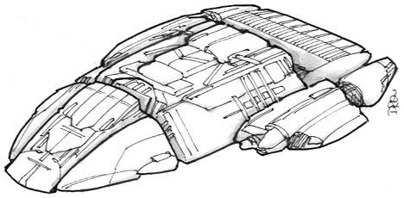
Manufacturer- Acamarian Engineering
Mass- 2,200,000 Metric Tons
Length- 575 Meters
Width- 260 Meters
Height- 60 Meters
Propulsion-
- 2x Class Four Hyper Matter Fusion LSD (Light Speed Drive) Coil Reactors
- 2x NEC Y74 Phased Plasma Sublight Engines in 2 Lateral Nacelles
- 1x NEC Y71 Phased Plasma Sublight Emergency Engine Inline Nacelles
Acceleration- Classified
Range- 40,000 Light Years
Compliment- 89 Officers; 458 Crew; 3000 Spartan Ground Troops or one full Armored Hover Brigade.
Sensors and Processing Systems-
- Nodon Engineering JCN Type 39 Tactical Networks
- Li’an Class XX Computer Core
- Hadarian Series Nine Bioscanners and Biofilters
Electronic Warfare and Decoys-
- Black Sun Mk VII EW Nodes
- TOPA Multi-Role System Decoy Launcher
Armament-
- 2 Quad Pulse Cannon Point Defense Turrets
Armor-
- Depleted Laminate Crystanium Weave molded with inner and outer Layers of Dragon Armor
- Three Type 90 Shield Generators
Aerospace Craft Carried- None
Number Active: 1,000
The Standard Heavy Troop Transport of the Lycavorian Union. There is little known terrain that could stop the VIPER-Class from off loading their troops. Armored Hover Brigade consists of sixteen S94 MHT and crews.

KADEN CLASS TRANSPORT
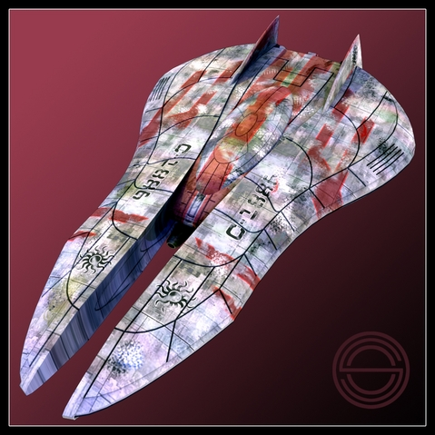
Manufacturer- Menkla Manufacturing
Mass- 87,000 Metric Tons
Length- 185 Meters
Width- 86 Meters
Height- 33 Meters
Propulsion-
- 1 Class Six Hyper Matter Fusion LSD (Light Speed Drive) Coil Reactor
- 2 NEC Z13 Phased Plasma Sub light Engines in 2 Lateral Nacelles
- 1 NEC Y71 Phased Plasma Sub light Emergency Engine Inline Nacelle
Acceleration- Classified
Range- 40,000 Light Years
Compliment- 4 Officers; Crew 29; Passengers 115; (when configured) 40,000 Metric Tons of varied supplies and equipment
Sensors and Processing Systems-
- Nodon Engineering JCN Type 43 Tactical Networks
- Li’an Class XX Computer Core
- Hadarian Series Nine Bioscanners and Biofilters
Electronic Warfare and Decoys-
- TOPA Multi-Role System Decoy Launcher (Military version only)
- 2 Whisper class Shroud Mk VIII generators (Military version only)
Armament-2 Quad Pulse Cannon Point Defense Turrets (Military version only)
Armor-
- Depleted Laminate Crystanium Weave
- Eight Type 90 Shield Generators (Military version only)
Aerospace Craft Carried- None
Number Active: 49
Designed to replace the aging MENKLA III transport for both civilian and military use. Special authorization was obtained from King Leonidas to allow use of the Hyper Matter Fusion Core LSD Coil Reactors in all military and some civilian models since building the smaller engine cores took less time. Civilian models will vary from normal transport to diplomatic carriers and personal yachts. Military variants to include many operational abilities that the current MENKLA IIIs do not possess.

WASP CLASS ASSAULT TRANSPORT
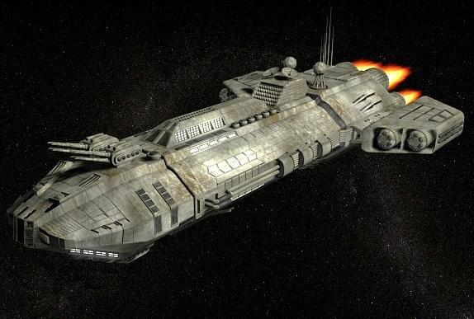
Manufacturer- Dreamland Shipyards
Mass- 475,000,000 Metric Tons
Length- 2800 Meters
Width- 1650 Meters
Height- 450 Meters
Propulsion-
- 4 Hyper Fusion Reactors
- 4 Mk XI Plasma Drives in 2 Nacelles
- 2 Quantum Fusion LSD Coils
Acceleration- Classified
Range- 30,000 Light Years
Compliment- 175 Officers; 1450 Enlisted; 80 Pilots; 12,000 Spartans plus six Armored Brigades
Sensors and Processing Systems-
- Nodon JCN Type 71 Tactical Network
- NorthAm Mk X Aegis FCS
- Li’an class XXV Computer Core
- Hadaria series Bioscanners and Biofilters
Electronic Warfare and Decoys-
- 8 Black Sun Mk XVII EW Nodes
- 10 Whisper class Shroud Mk VIII generators
- 4 Multi-Role System Decoy Launchers
Armament-
- 24 Type 2 (Mk9C Alpha Series) Plasma Turrets-4 Bow/8Starboard/8 Port/4 Aft
- 16 Quad Pulse Cannon PDTs
- 4 5-Rack PD Missile Clusters- 2 Bow/2 Aft
- 12 MRLS (grounded use only)
- 8 45cm Paladin Mk XII Plasma Artillery (ground use only)
Armor-
- Depleted Laminate Crystanium Weave molded with inner and outer Layers of Dragon Armor
- Eight Type 90 Shield Generators
Aerospace Craft Carried-
- 24 STRIKER ATs
- 12 Raptor IIA3
Number Active: 3
Construction ongoing
With the Viper class Troop Ship showing its age, and the threat of future Kavalian encounters rising, the Union Naval Command issued a directive to the Special Projects Division to look into a new ship to replace the Viper. Admiral O’Conner’s team worked quickly to establish the parameters of the design, deciding on one ship to take the place of ten Viper class ships. With the advances in technology developed from City Ship 41, the Wasp would be one of the largest ships to land on a planet. This would allow the Wasp to deploy its forces into the battle either directly or indirectly using its Striker ATs and Raptor IIA3s. WASP is equipped with a pressure-sealed hanger with can be isolated from the rest of the ship permitting launching its Strikers and Raptors from orbit.
Raptor IIA3s are similar to the IIE3in appearance but configured to transport armor.

TYPE I DRAGON TRANSPORT
(All are assigned to Arzoal)
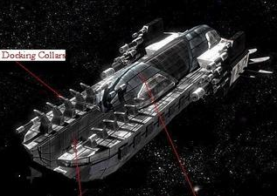
Manufacturer- Nodon Engineering Corporation
Mass- 683,000 Metric Tons
Length- 403 Meters
Width- 47 Meters
Height- 21 Meters
Propulsion-
- 1x Class Six Hyper Matter Fusion LSD (Light Speed Drive) Coil Reactors
- 2x NEC Y74 Phased Plasma Sublight Engines in 2 Lateral Nacelles
Acceleration- Classified
Range- Classified
Compliment- 3 Crew: Pilot, Co-pilot, Flight Engineer; 400 full grown dragons
Sensors and Processing Systems-
- Nodon Engineering JCN Type 51 Tactical Networks
- NorthAm Mk X Aegis FCS
- Li’an Class XXIV Computer Core
- Hadarian Series Nine Bioscanners and Biofilters
Electronic Warfare and Decoys-
- Black Sun Mk XVII EW Nodes
Armament-
- 2 Quad Pulse Cannon Point Defense Turrets
Armor-
- Depleted Laminate Crystanium Weave molded with inner and outer layer of reinforced Dragon Armor
Aerospace Craft Carried-
- None
Number Active: 247
Based on the design of an ore carrier the TYPE I was built to carry 400 Dragons enabling the Dragon Elder Mother and her kind to move freely from place to place within the Union. Holding four hundred dragons or a mixture of full grown, adolescent or Dragon eggs, the ships are primarily staged out of Elear and Earth. It allows the Dragons to fully participate with the Union government and allow others to know that they truly do exist.

TYPE IA DRAGON ATTACK TRANSPORT
1st Dragon Brigade
Manufacturer- Nodon Engineering Corporation
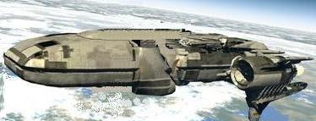
Mass- 683,000 Metric Tons
Length- 873 Meters
Width- 97 Meters
Height- 36 Meters
Propulsion-
- 1x Class Six Hyper Matter Fusion LSD (Light Speed Drive) Coil Reactors
- 2x NEC Y74 Phased Plasma Sublight Engines in 2 Lateral Nacelles
Acceleration- Classified
Range- Classified
Compliment- 47 Crew: Pilot, Co-pilot, Flight Engineer, Weapons Officer and Tactical Control Officer; 600 fully grown dragons
Sensors and Processing Systems-
- Nodon Engineering JCN Type 71 Tactical Networks
- NorthAm Mk X Aegis FCS
- Li’an Class XXIV Computer Core
- Hadarian Series Nine Bioscanners and Biofilters
Electronic Warfare and Decoys-
- Black Sun Mk XVII EW Nodes
- 4 Whisper Class Mk VIII Shroud Generators
Armament-
- 4 Type 2 Plasma Turrets (MK9C Alpha Series 1) 2 Port Side Forward and Aft, 2 Starboard Side Forward and Aft
- 1 Mark 22B Anti-Ship Missile Batteries w/Launcher
- 2 Photonic Torpedo Launchers
- 2 Quad Pulse Cannon Point Defense Turrets
Armor-
- Depleted Laminate Crystanium Weave molded with inner and outer Layers of Dragon Armor
- Two Type 90 Shield Generators
Aerospace Craft Carried-
- None
Number Active: 6
construction on-going
The newest and most advanced large Dragon Transport. Based on the original design TYPE I, the TYPE I Alpha was built to carry the 1st Dragon Brigade into battle and no cost was spared. The TYPE I Alpha is over 200 meters longer, and extremely well powered with its Class Six Hyper Matter Fusion Engine. Maintaining the ability to land planet side and with its advanced shields and the best Shroud Generators available, the TYPE I Alpha can deposit the Dragon Brigade nearly anywhere it needs to go in order to support operations. With a Flight Crew of five and then 42 Dragon Brigade Support crew, the TYPE I Alpha’s future within the Union Fleet is well assured.

TYPE II DRAGON TRANSPORT
(Assigned to the Dragon Elder Council)
Manufacturer- Nodon Engineering Corporation
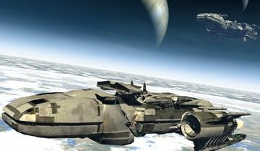
Mass- 183,000 Metric Tons
Length- 151 Meters
Width- 31 Meters
Height- 16 Meters
Propulsion-
- 1x Class Six Hyper Matter Fusion LSD (Light Speed Drive) Coil Reactors
- 2x NEC Y74 Phased Plasma Sublight Engines in 2 Lateral Nacelles
Acceleration- Classified
Range- 50,000 Light Years
Compliment- Pilot, Co-pilot, Flight Engineer; 40 Fully Grown Dragons Standard
Sensors and Processing Systems-
- Nodon Engineering JCN Type 61 Tactical Networks
- NorthAm Mk X Aegis FCS
- Li’an Class XXIV Computer Core
- Hadarian Series Nine Bioscanners and Biofilters
Electronic Warfare and Decoys-
- Black Sun Mk XVII EW Nodes
Armament-
- 4x Quad Pulse Cannon Point Defense Turrets
- 2x Dual Mount Point Defense Missile System
Armor-
- Depleted Laminate Crystanium Weave molded with inner and outer Layers of Dragon Armor

Aerospace Craft Carried- None
Number Active: 201
Construction on-going
Based on the design of an obsolete Elven built Freighter the TYPE II Dragon Transport was built to carry 40 Dragons and a full platoon of Union soldiers or passengers. Staged from half a dozen locations throughout the Union they are the only Dragon Transport of size to be able to land at surface spaceports and are used primarily for the safe and quick transport of the Dragon Elder Council to places where a presence of the dragon species is needed for show. Due to its designed the Type II was used as the blueprint for the larger Type IAs currently in use with the Dragon Brigade. They are also the primary short range Dragon Transport from surface to orbit since they are easily taken into the landing bay of the larger Union warships capable of accommodating dragons.

STRIKER DT DRAGON ATTACK TRANSPORT
(Mjolner’s Hand Standard)
Manufacturer- Nodon Engineering Corporation
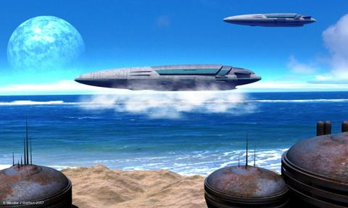
Mass- 9,000 Metric Tons
Length- 82 Meters
Width- 45 Meters
Height- 16 Meters
Propulsion-
- 1x Class Six Hyper Matter Fusion LSD (Light Speed Drive) Coil Reactors
- 2x NEC Y74 Phased Plasma Sublight Engines in 2 Lateral Nacelles
Acceleration- Classified
Range- 50,000 Light Years
Compliment- 2-3, Pilot, Co-pilot, Flight Engineer; 2 Fully Grown Dragons Standard, 35 Member Assault Team.
Sensors and Processing Systems-
- Nodon Engineering JCN Type 51 Tactical Networks
- NorthAm Mk X Aegis FCS
- Li’an Class XXIV Computer Core
- Hadarian Series Nine Bioscanners and Biofilters
Electronic Warfare and Decoys-
- Black Sun Mk XVII EW Nodes
- 1 Whisper Class Mk VIII Shroud Generators
Armament-
- 4 Type 1 Plasma Turrets (MK9C Alpha Series 1) 2 Port Side Forward and Aft, 2 Starboard Side Forward and Aft
- Mark 22B Anti-Ship Missile Batteries w/Launcher.
- 2 Photonic Torpedo Launchers
- 2 Quad Pulse Cannon Point Defense Turrets
Armor-
- Depleted Laminate Crystanium Weave molded with inner and outer Layers of Dragon Armor
- Two Type 90 Shield Generators
Aerospace Craft Carried- None
Number Active: 350
Standard Transport for Mjolnir's Hand and all Bonded Pairs within the Union. Living quarters for flight crew and riders can act as Tactical Unit Operational Hub if needed. It is capable of sustained atmospheric operation with a smooth transition to space flight. Entire forward cockpit section detaches as escape pod.

STRIKER DT IIA DRAGON ATTACK TRANSPORT
(Future replacement for original DT)
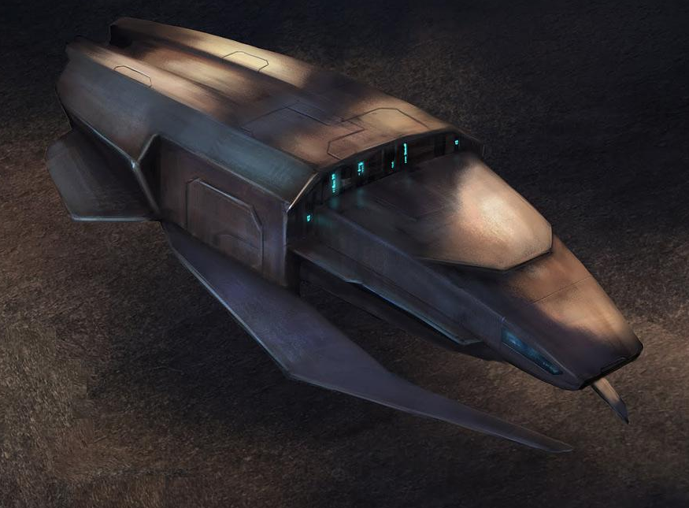
Manufacturer- Nodon Engineering Corporation
Mass- 19,000 Metric Tons
Length- 122 Meters
Width- 55 Meters
Height- 21 Meters
Propulsion-
- 1 Class Six Hyper Matter Fusion LSD (Light Speed Drive) Coil Reactor
- 2 NEC Y74 Phased Plasma Sublight Engines in 2 Lateral Nacelles
Acceleration- Classified
Range- 70,000 Light Years
Compliment- 2-3, Pilot, Co-pilot, Flight Engineer; 4-5Full Grown Dragons Standard;
35 Member Assault Team
Sensors and Processing Systems-
- Nodon Engineering JCN Type 71 Tactical Networks
- NorthAm Mk X Aegis FCS
- Li’an class XXV Computer Core
- Hadaria series Bioscanners and Biofilters
Electronic Warfare and Decoys-
- Black Sun Mk XVII EW Nodes
- 2 Whisper Class Mk VIII Shroud Generators
Armament-
- 4 Type 2 Plasma Turrets (MK9C Alpha Series 1)
- 2 Mark 22B Anti-Ship Missile Batteries w/Launchers
- 2 Photonic Torpedo Launchers
- 2 Quad Pulse Cannon Point Defense Turrets
Armor-
- Depleted Laminate Crystanium Weave molded with inner and outer Layers of Dragon Armor
- Two Type 90 Shield Generators
Aerospace Craft Carried-
- None
Number Active: 8
Construction ongoing
This ship will become the standard transport for Mjolnir's Hand and all Bonded Pairs within the Union. Living quarters for flight crew and riders can act as Tactical Unit Operational Hub if needed. It is capable of sustained atmospheric operation with a smooth transition to space flight. Entire forward cockpit section detaches as escape pod. The STRIKER DT IIA allows for two additional Dragons with a fifth possible in detachable harness. Pilot’s quarters enlarged for additional bunk and space over long flights. Main quarters enlarged on some variants to allow for Royal Family transport with additional personnel. The IIA variants will begin to supplement and then replace current versions of STRIKER DTs over an estimated six year period. Initial program variants will be restricted to Royal Family and other indicated parties.

HEALER CLASS MEDICAL SHIPS
While not a fighting ship, these 3000 bed medical ships staffed almost entirely of Hadarian Healers are deployed with the fleet in support of ground operations and elsewhere when needed. Twenty-seven are currently in service and they are equipped with the most advanced medical equipment anywhere in the universe. These ships will carry a new MEDEVAC (medical evacuation) variant of the Striker Attack Transport, developed and equipped with the most advanced medical facilities for combat trauma care and transport as devised by Queen Anja and Hadarian Queen Eurin.
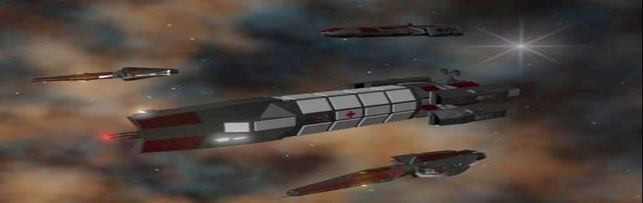
Full technical dimension, loads, and performance data are not available.

PART 2 Aerospace Craft

M7 TEMPEST FIGHTER INTERCEPTOR
The Premier Union Fighter
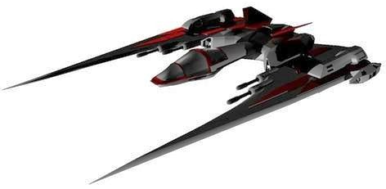
Manufacturer- Nodon Engineering Corporation
Mass- 18 Metric Tons
Length- 26 Meters
Wingspan- 19 Meters
Height- 5 Meters
Propulsion-
- Two primary JLX-3500 Fusion Plasma Drives
- Two secondary JLX-2000 Fusion Plasma Drives
- Two wing-mounted XLM-800 Enhanced Maneuver Verners
Acceleration- Classified
Range- 5,000 Light Years
Compliment- 1 Pilot
Sensors and Processing Systems-
- Nodon Engineering JCN Type 39 Tactical Networks
- Li’an Class 6 Computer Core
Electronic Warfare and Decoys-
- 1 Black Sun Mk V EW Node
- Fighter Multi-Role System Decoy Launcher
Armament-
- Advanced Targeting Sensor Pod
- 2 30mm Pulse Cannons
- 2 20mm Pulse Cannons
- 2 SMPD Swarm Missile Pods (50 missiles per pod)
Armor-
- Laminate Dragon Armor Weave
The M7 Tempest is Premier Fighter/Interceptor in the Union inventory. It is rapidly being distributed to all Fleet Commands for replacement of the all older fighters. With unmatched speed and maneuverability, the M7 Tempest can be given many roles.

M5A DEVASTATOR FIGHTER BOMBER
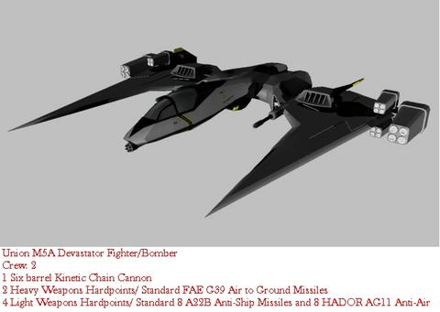
Manufacturer- Nodon Engineering Corporation
Mass- 26 Metric Tons
Length- 23 Meters
Wingspan- 26 Meters
Height- 4 Meters
Propulsion-
- 2x JLX-3500 Fusion Plasma Drives
- 1x JLX-2000 Fusion Plasma Drives
- Four Tertiary SCJ-77 Booster Drives
Acceleration- Classified
Range- 5,000 Light Years
Compliment- 2 Officers; 1 Pilot, 1 WSO — M5A Penetrator Variant: 1 Pilot, 1 ESO
Sensors and Processing Systems-
- Nodon Engineering JCN Type 39 Tactical Networks
- Li’an Class 6 Computer Core
Electronic Warfare and Decoys-
- 1 Black Sun Mk V EW Node
- Fighter Multi-Role System Decoy Launcher
Armament-

M5A Devastator Fighter Bomber
1- 6-barrel 40mm Rotary Kinetic Cannon
2- 20mm Pulse Cannons
4- Multi-role Missile Pods
2- Heavy Anti-ship Pods

M5A Penetrator Variant
Advanced Targeting Sensor Pod in nose
2 Heavy Pods with 3-rack ECM/ECCM Drone Launcher
2 MRM Pods with 2 ECM/ECCM Sensor Pods
2 MRM Pods with 2 SMPD Pods

Armor-
Laminate Dragon Armor Weave

M5A Devastator Fighter Bomber
The standard class Fighter/Bomber in the Union inventory. Re-invented once Ben O'Connor became head of Union Operations and he saw the need for a dedicated Ground Support and Heavy Fighter role. Extremely fast and nimble for a Fighter Bomber and packing a deadly weapons load.
M5A Penetrator Variant
Based on the Devastator model, the Penetrator Variant is another of Ben O’Connor’s visions. A dedicated Electronic Warfare aircraft with the speed of a fighter. The Penetrator Variant has the most advanced fighter avionics ever devised by Union engineers and just one of these craft mixed in with a Squadron of Devastators can spell doom for any enemy ship not at the top of their game.

RAPTOR IIE3 (ELINT)
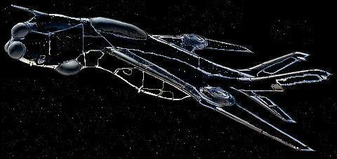
Manufacturer- United Earth Engineering
Mass- 80,000 Metric Tons
Length- 67 Meters
Wingspan- 15 Meters
Height- 22 Meters
Propulsion- Classified
Acceleration- Classified
Range- Classified
Compliment- 4 Pilots, 2 flight Engineers, 8 technicians; can carry full second crew for long duration missions
Sensors and Processing Systems-
- Nodon JCN Type 71 Tactical Network
Electronic Warfare and Decoys-
- Classified
Armament-
- Classified
Armor-
- Double layered outer hull composed of matte black Dragon Armor
Raptors IIE3s are the extreme long range eyes and ears of the ARIZONA’S Attack Wing. They were built for stealth and speed. She is all but invisible to the naked eye, and while she has no Shrouds, thanks to some very advanced Stealth screens improved upon by Avi, she is effectively invisible to all known sensors. (Photo enhanced to show general features.)
A Commander can use the Raptor’s ELINT ability to survey and catalog all electronic signals far ahead of the fleet. Stationed on the periphery of an engagement, Raptors can selectively suppress all enemy electronic signals and jam their sensors rendering the enemy “blind, deaf, and mute.”
Given these capabilities, Raptors will also deploy with normal fleet groups as needed.

Photo credits:
Pralor Vortex Cruiser – Jim
Arizona - thelordofthestorms
Leonidas II – unknown from internet
Leonidas I – M.J. Graham
Moonlancer – Zaon Studios, Inc.
Nova – thelordofthestorms
Vanguard – thelordofthestorms
Admiral Ceneu - Zaon Studios, Inc.
Taur'Ohtar – thelordofthestorms
Autumn Moon – thelordofthestorms
Omen - unknown from internet
Drow Interceptor - unknown from internet
Striker AT - unknown from internet
Viper – DRE
Kaden - unknown from internet
Wasp – Andiran Tiba
Type I - unknown from internet
Type IA – B Stafford (modified)
Type II – B. Stafford
Striker DT - M.J. Graham
Striker DT IIA –Ozan Civit
Kaden - unknown from internet
Healer – thelordofthestorms
M7 – thelordofthestorms
M5 – thelordofthestorms
Raptor – Earth Alliance Forces

? AVI to King Leonidas

